TECHNICAL ARCHITECTURE
Technical Architecture
The ShopEZ application follows a three-tier architecture consisting of Frontend, Backend, and Database layers.
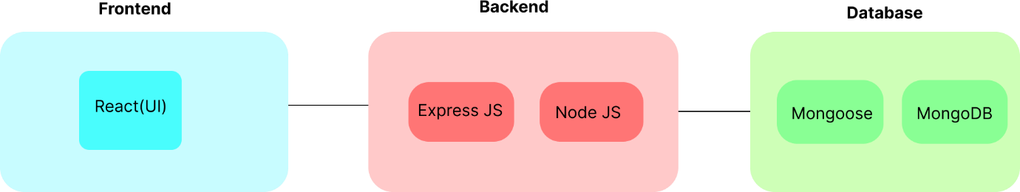
Frontend Layer:
The frontend is developed using React.js and provides an interactive user interface for users and administrators. It includes modules such as User Authentication, Products, Cart, Profile, Orders, and Admin Dashboard.
Backend Layer:
The backend is developed using Node.js and Express.js. It consists of API endpoints for Users, Orders, Products, Authentication, and Admin functionalities. The backend processes user requests and communicates with the database.
Database Layer:
MongoDB is used as the database management system. It stores collections such as Users, Products, Cart, Orders, and Admin information.
System Workflow:
1.Users interact with the React frontend.
2.Frontend sends API requests to the backend.
3.Backend processes the requests.
4.MongoDB stores and retrieves data.
5.Backend sends responses to the frontend.
6.Frontend displays the results to the users.

